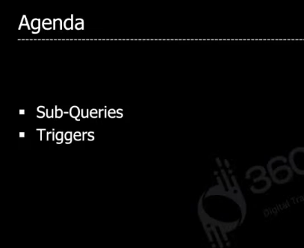

**JOIN WITH MORE THAN TWO TABLE**

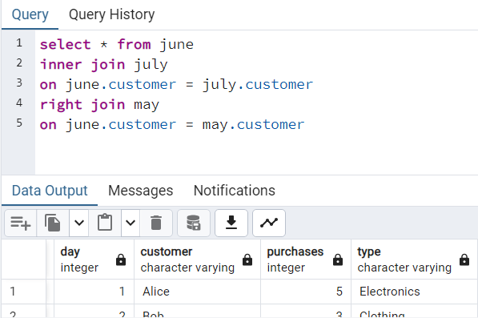

**TYPES OF SUB QUERY:**

There are two main types of subqueries in SQL:

1. **Correlated Subquery:** Depends on the outer query for its values; evaluated row by row.
2. **Non-Correlated Subquery:** Independent of the outer query; evaluated only once.

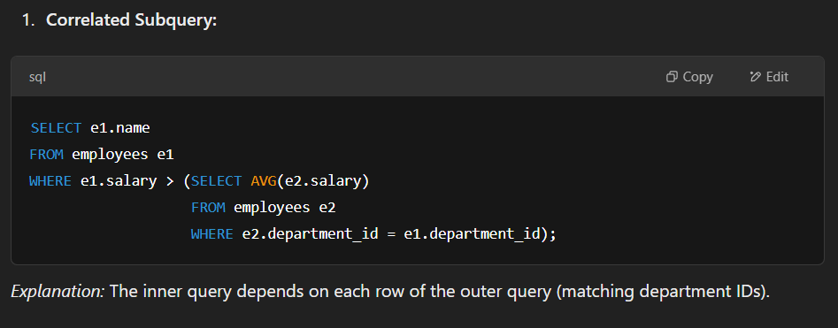

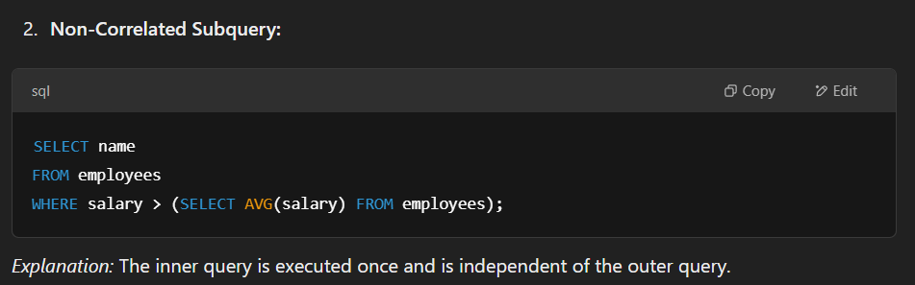

**SUB QUERY**

In the sub query the inner query runs first and then the outter query will run.

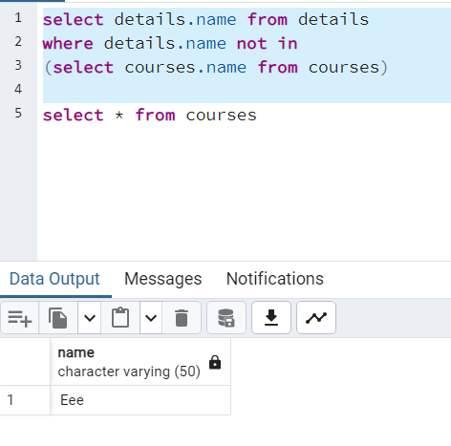

**TIGGER**

A function that can be invoked while make insertion, updating, deleting a record.

**Function for trigger**

Assume we are going calculate price by quantity for purchase column while inserting a record with quantity and price, following this way we declare functions in postgres sql, it uses $$ for the starting and ending point of the function, declare are used to declare local variable.

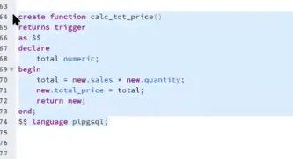

All the created function can be viewed in trigger function section

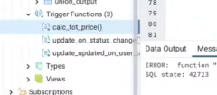

**Creating trigger to invoke the function**

